Title of the Article

Author¹, Author², Author³
^{1,2,3}Affliation (Name of Dept., Name of College, State, Country)

Abstract
Phase Change Materials (PCMs) have emerged as an effective solution for enhancing thermal energy storage and improving the energy efficiency of building envelopes in both residential and commercial structures. This study investigates the thermal performance of PCMs when integrated into building wall systems under varying climatic conditions. Experimental wall prototypes incorporating paraffin-based PCMs were subjected to controlled heat flux to evaluate thermal lag, peak temperature reduction, and energy-saving potential. The results showed that PCM-enhanced walls significantly reduced indoor temperature fluctuations, lowering peak temperatures by 4–7°C compared to conventional brick walls..
.
Keywords: Phase Change Material; Thermal Energy Storage; Building Envelope; Heat Transfer; Energy Efficiency; Passive Cooling

1. Introduction
Energy consumption in buildings has increased significantly over the past few decades due to growing population, improved living standards, and urban expansion. A major portion of building energy use is attributed to space heating and cooling, which are heavily influenced by external climatic conditions and building envelope performance. In regions experiencing high diurnal temperature fluctuations, wall systems act as major pathways for heat transfer, resulting in elevated indoor temperatures during the day and rapid cooling during nighttime. Conventional wall materials such as brick, concrete, and hollow blocks possess limited thermal storage capacity and allow heat to penetrate rapidly into the interior spaces, increasing the need for mechanical cooling systems and thereby contributing to higher energy consumption.

2. Literature Review
The integration of Phase Change Materials (PCMs) into building envelopes has been extensively studied due to their potential to improve thermal comfort and energy efficiency. Early investigations by Telkes (1975) demonstrated that PCMs can effectively store thermal energy through latent heat mechanisms, offering higher energy storage density compared to sensible storage materials. Subsequent studies focused on developing suitable PCM formulations for building applications, with paraffin-based and salt-hydrate PCMs gaining widespread acceptance due to their thermal stability and

3. System Design
The methodology for this study involved the development and experimental evaluation of wall panels integrated with paraffin-based Phase Change Materials (PCMs) to assess their thermal performance under controlled heat flux conditions. Three wall prototypes were constructed for comparative analysis: (i) a conventional brick masonry wall, (ii) a PCM- detailed understanding of PCM thermal behavior, storage efficiency, and their potential impact on improving building energy performance.
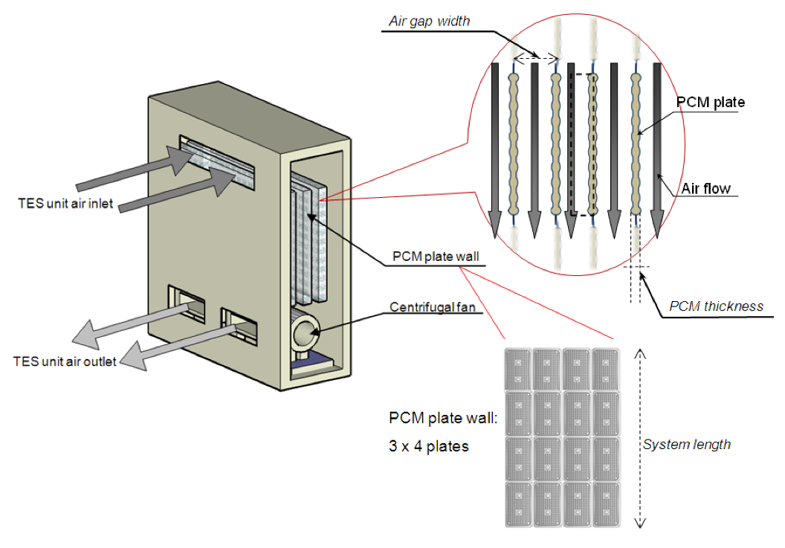
Figure 1. PCM-Integrated Wall Panels, Heat Flux Sensors, and Temperature Measurement Layout

4. Results & Discussion
The experimental evaluation of PCM-integrated wall systems demonstrated a significant improvement in thermal performance compared to the conventional brick wall, particularly in terms of peak indoor temperature reduction, thermal lag, and attenuation of heat flux. The results clearly indicate that Phase Change Materials, when properly integrated within the building envelope, can substantially enhance energy efficiency by reducing the rate of heat transfer during high-temperature periods.

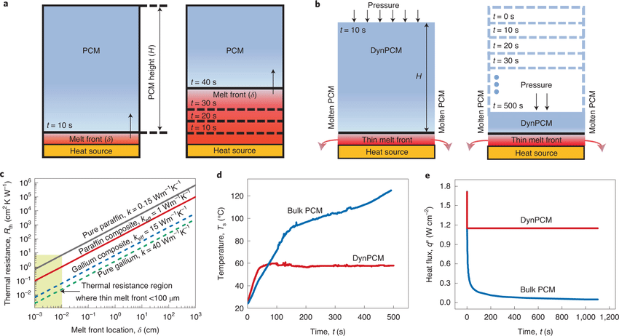Figure 2. Comparison of Temperature Profiles and Heat Flux for Conventional and PCM-Integrated Wall Systems Under Controlled Heating Cycles

5. Conclusion
The experimental investigation clearly demonstrates that integrating Phase Change Materials (PCMs) into building wall systems significantly enhances their thermal performance and contributes to improved energy efficiency. PCM-enhanced walls effectively reduced indoor peak temperatures by 4–7°C compared to conventional brick walls, owing to the latent heat absorption during the melting phase.

References
[1] Telkes, M., “Thermal storage in solar heating systems,” Solar Energy, vol. 19, pp. 299–300, 1975.
[2] Zalba, B., Marín, J. M., Cabeza, L. F., and Mehling, H., “Review on thermal energy storage with phase change materials,” Applied Thermal Engineering, vol. 23, pp. 251–283, 2003.
[3] Darkwa, K., and Kim, J., “Thermal performance of PCM-embedded gypsum boards,” Energy and Buildings, vol. 43, pp. 302–308, 2011.
[4] Kuznik, F., David, D., Johannes, K., and Roux, J. J., “A review of PCM-enhanced building components,” Renewable and Sustainable Energy Reviews, vol. 15, pp. 379–391, 2011.
[5] Tyagi, V. V., Kaushik, S. C., Tyagi, S. K., and Akiyama, T., “PCM-based passive cooling in buildings,” Renewable and Sustainable Energy Reviews, vol. 14, pp. 2583–2598, 2014.
[6] Voelker, C., Kornadt, O., and Ostry, M., “PCM integration for thermal comfort in lightweight buildings,” Energy and Buildings, vol. 40, pp. 937–944, 2008.
[7] Castell, A., Medrano, M., Roca, J., and Cabeza, L. F., “Simulation of PCM performance in building envelopes,” Energy and Buildings, vol. 42, pp. 1675–1685, 2010.
[8] Sharma, R., Agarwal, N., and Tiwari, P., “Thermal performance of PCM walls under Indian climatic conditions,” Journal of Building Engineering, vol. 12, pp. 63–71, 2017.

